Paper 1
Compare and contrast Text 1 and Text 2 below. In your comparative analysis, comment on the importance of context, audience, purpose and structural and stylistic devices.
Text 1
From 'Cranes'
Jennifer Ackerman
National Geographic 2004
From a blind overlooking the wetlands of central Wisconsin, I can see a long-legged bird in the distance, a stroke of white curled at the top, like a bright question mark against the emerald green grasses. Then up pops another from the screen of reeds. The birds are yearlings, five feet tall, with snow-white plumage and elegant black wing tips that spread like fingers when they fly. They’re quiet now, but from the long trachea coiled in their breastbones may come a wild, singing whoop, harsh and thrilling, that gives their tribe its name.
This would be a primordial scene – big sky, undulations of tall marsh grasses, wild whooping cranes – were it not for a penned area nearby, where several whooper chicks, well camouflaged in tawny feathers, forage in the shallows. In a whisper, crane biologist Richard Urbanek explains that these chicks have been raised in captivity but have never heard a human voice nor seen a human form, except in crane costume. As part of an experimental program to reintroduce a wild migratory population of whooping cranes to the eastern half of North America, these chicks have been fed and tended by crane-costumed people for two months. Now, before they are released to the wild, they are being taught the habits of their ancestors with modern techniques pioneered by Operation Migration, an organization devoted to helping endangered birds learn their traditional migratory routes. Near the pen is a long stretch of open grass, a runway, where the chicks are learning to fly behind an ultralight plane flown by a pilot in crane costume who will guide them from this refuge 1,200 miles south across seven states to wintering grounds in Florida.
Two cohorts have already made such trips – and returned on their own, the first whooping cranes in perhaps more than a century to fly freely over the eastern United States. After three years of ultralight-led migrations, the new eastern migratory population numbers 36 birds, including the yearlings and the chicks. The success of this effort is leading the way for a more ambitious project half a world away in the northern reaches of Russia. In the fall of next year an international migratory route, from Russia to Iran, will restore the birds’ knowledge of the ancient flyway – not with ultralights but with hang gliders that will soar a difficult path extending more than 3,000 miles over four different countries.
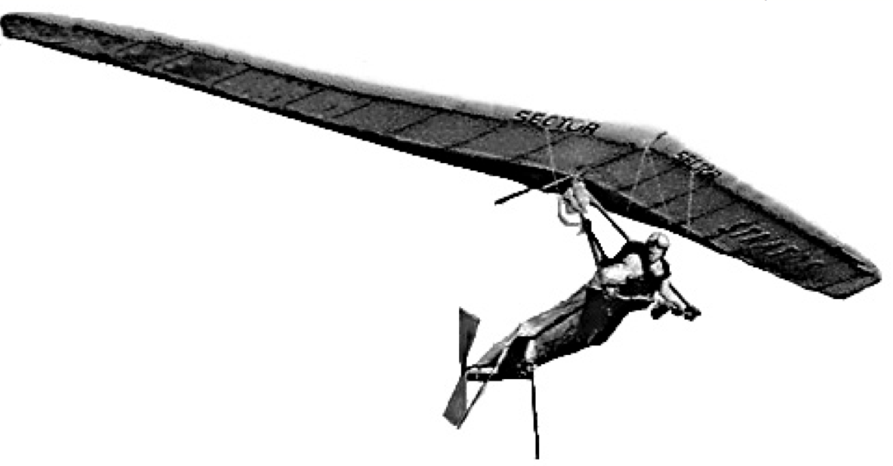Hang glider pilot Angelo d’Arrigo leads a trio of young captive-bred Siberian cranes on a trial flight over the Arctic Circle in Siberia – part of an ambitious effort to teach the endangered birds the migration route of their ancestors from Russia to Iran.

Text 2
'To a Waterfowl'
William Cullen Bryant
1815
Whither, 'midst falling dew,
While glow the heavens with the last steps of day,
Far, through their rosy depths, dost thou pursue
Thy solitary way?
Vainly the fowler's eye
Might mark thy distant flight to do thee wrong,
As, darkly painted on the crimson sky,
Thy figure floats along.
Seek'st thou the plashy brink
Of weedy lake, or marge of river wide,
Or where the rocking billows rise and sink
On the chafed ocean side?
There is a Power whose care
Teaches thy way along that pathless coast,--
The desert and illimitable air,--
Lone wandering, but not lost.
All day thy wings have fann'd
At that far height, the cold thin atmosphere:
Yet stoop not, weary, to the welcome land,
Though the dark night is near.
And soon that toil shall end,
Soon shalt thou find a summer home, and rest,
And scream among thy fellows; reed shall bend
Soon o'er thy sheltered nest.
Thou'rt gone, the abyss of heaven
Hath swallowed up thy form; yet, on my heart
Deeply hath sunk the lesson thou hast given,
And shall not soon depart.
He, who, from zone to zone,
Guides through the boundless sky thy certain flight,
In the long way that I must tread alone,
Will lead my steps aright.

